ENGLISH 8 – UNIT 9: NATURAL DISASTERS
VOCABULARY – PRONUNCIATION
(STRESS IN WORDS ENDING IN –LOGY AND -GRAPHY
A. New words:

disaster (n) | Thảm họa
Happen (v) | Xảy ra
Typhoon (n) | Bão
Tropical storm (n) | Bão nhiệt đới
Terrible (adj) | Khủng khiếp
Severe (adj) | Nghiêm trọng
Injured (adj) | Bị thương
Injury (n) | Vết thương
Report (v, n) | Báo cáo
Property (n) | Tài sản
Destroy (v) | Phá hủy
Flood (n) | Lũ lụt
Homeless (adj) | Vô gia cư
Awful (adj) | Kinh khủng
Technology (n) | Công nghệ
Against (pre) | Chống lại
Rescue N,(v) | Cứu hộ, giải cứu
Trap (v, n) | Bẫy
Debris (n) | Mảnh vụn
Equipment (n) | Dụng cụ
Temporary (adj) | Tạm bợ
Extensive (adj) | Mở rộng
Volcanic (adj) | Thuộc núi lửa
Eruption (n) | Sự phun trào
Tornado (n) | Cơn lốc xoáy
Mud slide (n) | Lũ bùn
Earthquake (n) | Động đất
Tsunami (n) | Sóng thần
Drought (n) | Hạn hán
Common (adj) | Thông thường
Strike (v) | Đánh, tấn công
Collapse (v) | Sụp đổ
Rage (v, n) | Cơn thịnh nộ, cơn giận dữ
Bury (v) | Chôn vùi
Shake (v) | Lắc rung
Erupt (v) | Phun trào
Shelter (n) | Chỗ ở, nơi trú ẩn
Aid (v) | Hỗ trợ, giúp đỡ
Evacuate (v) | Sơ tán, rút lui
Scatter (v) | Rắc, vung vãi
Wind (n) | Cơn gió
Resident (n) | Cư dân
Predict (v) | Tiên đoán
Accurate (adj) | Chính xác
Medical supply (n) | Thuốc men, dụng cụ y tế
Area (n) | Vùng
Organize (v) | Tổ chức
Victim (n) | Nạn nhân
Raise money (v) | Quyên góp tiền
Manage (v) | Quản lí, xoay sở
Climate change (n) | Biến đổi khí hậu
In charge | Chịu trách nhiệm
Global warming (n) | Sự nóng lên toàn cầu
Knowledge (n) | Kiến thức
Prepare (v) | Chuẩn bị
Respect (v) | Tôn trọng
Wreak havoc (v) | Phá hủy
Weather bureau (n) | Phòng dự báo tời tiết
Powerful (adj) | Mạnh mẽ
Violent (adj) | Dữ dội
Survivor (n) | Người sống sót

Những từ có tận cùng –logy/ -graphy thì trọng âm rơi vào âm tiết liền kề trước nó.
Example: bi’ology, ge’ography, e’cology, au’tography

B. Practice
I. Stress: Circle the word with a different pattern from the other
1.A. ecology | B. environment | C. autography | D. residential
2.A. industry | B. tornado | C. natural | D. injury
3.A. geography | B. electronic | C. scientific | D. preparation
4.A. debris | B. rainstorm | C. destroy | D. shelter
5.A. primary | B. animal | C. tropical | D. volcano
6.A. climatology | B. bibliography | C. communication | D. radiography
7.A. astrology | B. unnatural | C. medication | D. demography
8.A. voluntary | B. apology | C. television | D. nationalize

II. Complete the word with –logy or –graphy then mark the stress syllable in each word
1. bio_______________ 2. video_________________
3. archaeo_________ 4. bio_________________
5. zoo_______________ 6. tele________________
7. techno_______________ 8. geo__________________
9. psycho_____________ 10. photo_______________

III. Match the natural disasters with the pictures
A. drought | B. earthquake | C. flood | D. forest fire | E. landslide
F. lightning | G. tornado | H. tsunami | I. typhoon | J. volcanic eruption

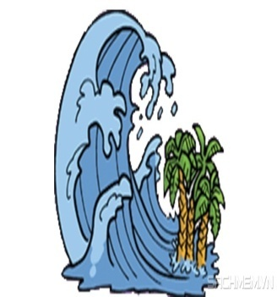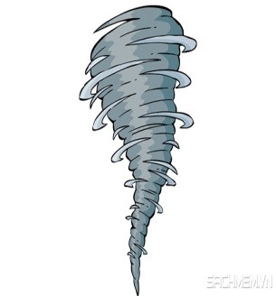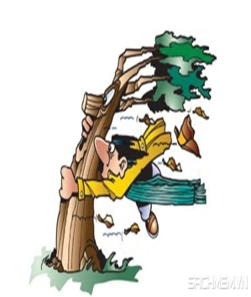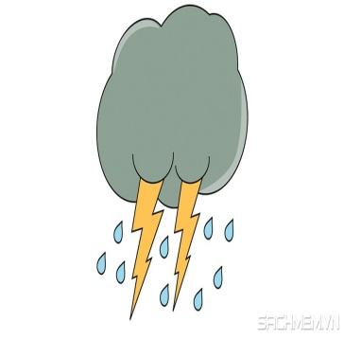
- 2. 3. 4.
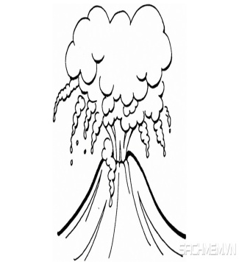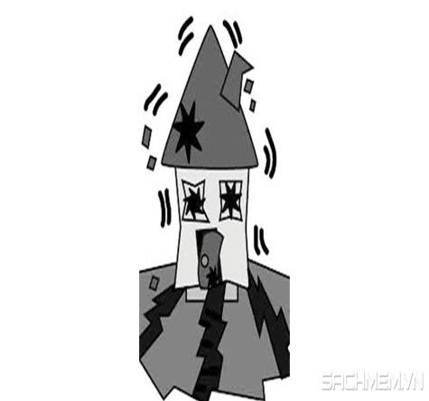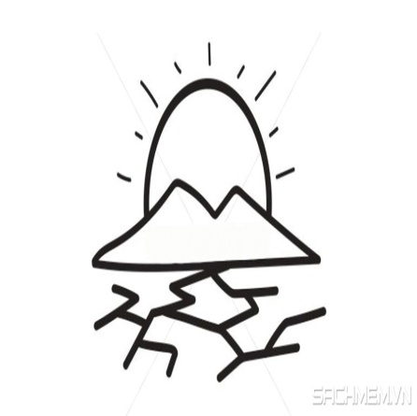
5. 6. 7.

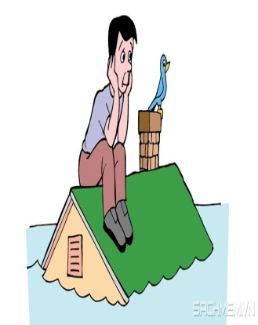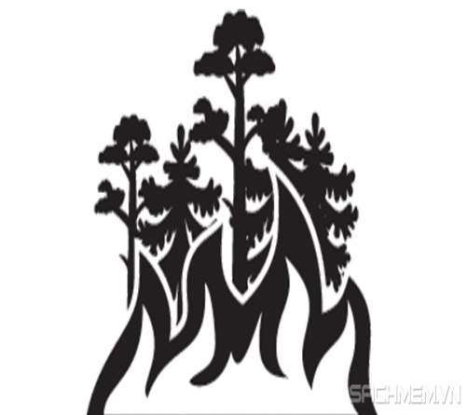
8. 9. 10.

IV. Complete the sentences with the words from the box
avalanche evacuation blizzard explosion disaster
flood drought lightning eruption tsunami

avalanche /'ævəlɑ:nʃ: tuyết lở
evacuation '''i¸vækju´eiʃən''' sự rút khỏi , sự sơ tán,
blizzard /''''blizəd'''/, Trận bão tuyết,
1. The soldiers have been deployed to help avert ('''ə´və:t'''Ngăn ngừa, ngăn chặn) a looming (hiện ra lờ mờ ; lờ mờ) environmental ____________in central provinces.
2. When I was outside in the ___________ , I couldn't see more than a few feet in front of me because of all the snow.
3. Mum went shopping yesterday afternoon and she was very frightened. In the car park, there was an _________ and nobody knew what it was.
4. I saw on TV that yesterday there was an________ on an island in the Pacific and hot lava came down the volcano.
5. My little sister is afraid of ____________, so when there is a bad storm she always hides.
6. Last Sunday we wanted to go skiing, but we couldn't because in the mountains there was an _____________.
7. A powerful earthquake off the coast of Indonesia sparked a three-metre-high ______________killed at least 113 people.
8. If there is a bad _______ in a town, the people have to travel by boat!
9. After the harshest winter in decades, the western region is now facing its hottest summer and the worst ________ across the area in nearly 40 years.
10. People should become familiar with the guidelines for ____________because natural disasters can force them to leave their homes.

